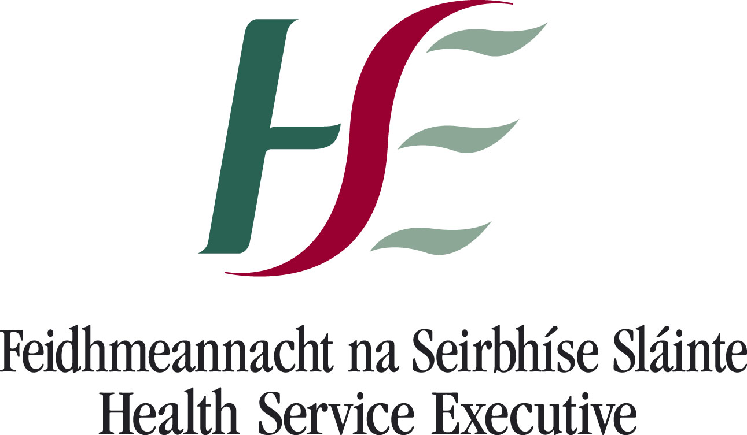
Office of the General Manager,
PCS Cavan & Monaghan,
Support Services Building,
Rooskey,
Monaghan.

Tel: +353 (0) 47 30496
Fax: +353 (0) 47 38532

E-mail: rose.mccaffrey@hse.ie

Cllr. John Paul Feeley,
Stranamorth,
Blacklion,
Co. Cavan

12th February 2015

Re: Lisdarn Care Centre & Breffni Care Centre GM1661

Dear Cllr. Feeley,

I refer to your correspondence of 2nd February 2015 in regard to the above. I have examined the matter and the following outlines the position.

A design team has been appointed and plans are being developed for an extension and refurbishment of Breffni Care Centre. This centre will when complete deliver 50 HIQA compliant beds. Work is expected to commence in Spring 2016.

Regarding the Lisdarn Unit, HSE Senior Management and HIQA recognise that there are significant infrastructural challenges in the Lisdarn Unit. The priority for both parties is to ensure that older people are cared for in an environment which ensures that their privacy and dignity are maintained at the highest level. HSE management are working closely with their colleagues in Estates and the staff in the Lisdarn Unit to finalise the capital works that will be carried out to maximise privacy and dignity of the older people being cared for in this unit, including works to address the environmental infrastructural challenges and it is expected that these works will be completed in June 2015.

I trust this information is of assistance to you but should you have any further queries please do not hesitate to contact me.

Yours sincerely
__________________________________
Rose McCaffrey,
General Manager,
PCS Cavan & Monaghan

